IT Employee Lifecycle Automation System
User Interface Specification
Stephen Torrijas

1. Overview
This document specifies the user interface design for the IT Employee Lifecycle Automation System.

UI Screen | Use Case(s) Covered | Primary Actor
UI-1: Main Dashboard | View Dashboard; Approve/Override Account Actions | IT Administrator
UI-2: Mapping Configuration | Configure Role-Permission Mappings | IT Administrator
UI-3: Task Detail (Modal) | Approve/Override Account Actions | IT Administrator
UI-4: Audit Log Viewer | View Audit Logs | IT Administrator
UI-5: Report Generation | Generate Compliance Reports | IT Administrator
UI-6: Employee Search | Search Employee Status | IT Administrator / HR Personnel

All screens share a common layout: a top navigation bar, a left sidebar for page navigation, and a main content area.

2. Preliminary Design

2.1 Global Layout and Navigation
Every screen will follow a consistent three-zone layout: a top bar, a left sidebar with navigation buttons and a main content area that changes per page. The active sidebar item is highlighted in blue. Inactive items use a white background. Breadcrumbs appear in the top bar on detail pages to help users track their current location.

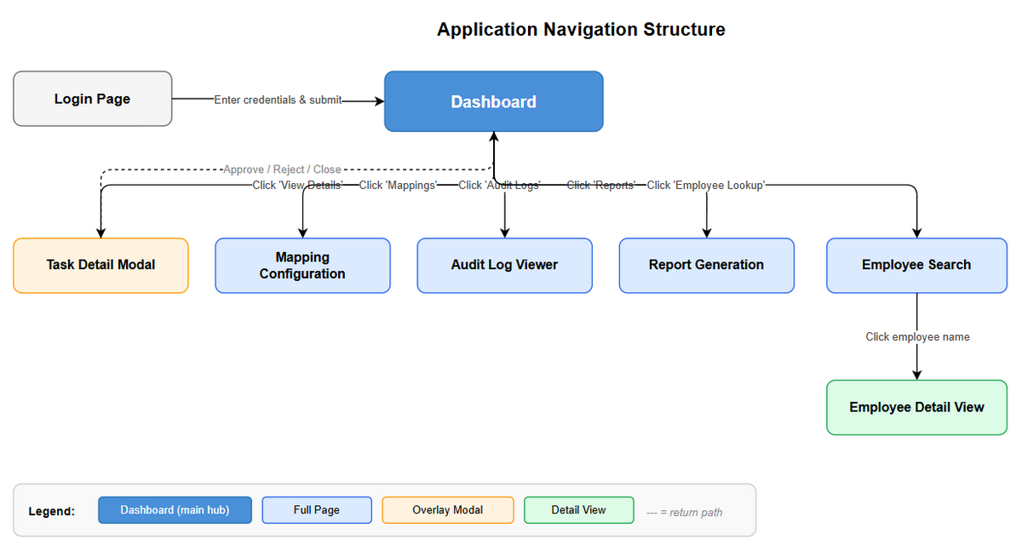

2.2 Use Case 1 — View Dashboard
The Main Dashboard is the default landing page after login. It gives the IT Administrator a real-time overview of all pending, in-progress, completed, and failed lifecycle tasks, together with summary statistics on the right panel.

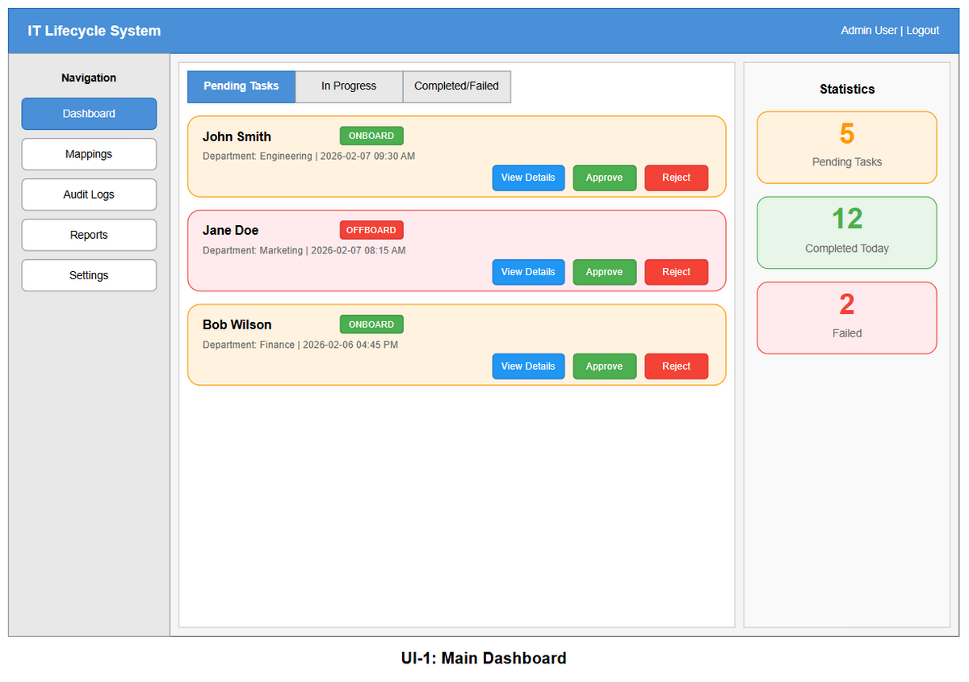

Input Controls and Buttons:
Control | Type | Location | Action
Pending Tasks | Tab | Main content, top | Filters the task list to pending tasks only
In Progress | Tab | Main content, top | Filters the task list to in progress tasks
Completed / Failed | Tab | Main content, top | Filters the task list to completed or failed tasks
View Details | Button (blue) | Per task card | Opens the Task Detail Modal for that task
Approve | Button (green) | Per task card | Immediately approves and queues the task for execution
Reject | Button (red) | Per task card | Prompts for a rejection reason and cancels the task

Display Elements: Each task is shown as a color-coded card with an orange border for onboarding tasks and a red border for offboarding tasks. Each card shows the employee name, a task type badge, the employee's department, and the timestamp when the task was created. The statistics panel on the right displays three live summary cards showing the counts of Pending Tasks, Completed Today, and Failed tasks.

Navigation: After logging in, users are automatically directed to the Dashboard. Clicking any of the three status tabs filters the task list in place without navigating away from the page. Clicking View Details on a task card opens the Task Detail Modal as an overlay on top of the Dashboard. Clicking any item in the left sidebar navigates to the corresponding full page.

2.3 Use Case 2 — Approve / Override Account Actions
The Task Detail Modal opens as an overlay when an administrator clicks View Details on a task card. It presents the full employee information, the list of proposed Active Directory actions, and override checkboxes before the administrator approves or rejects the task.

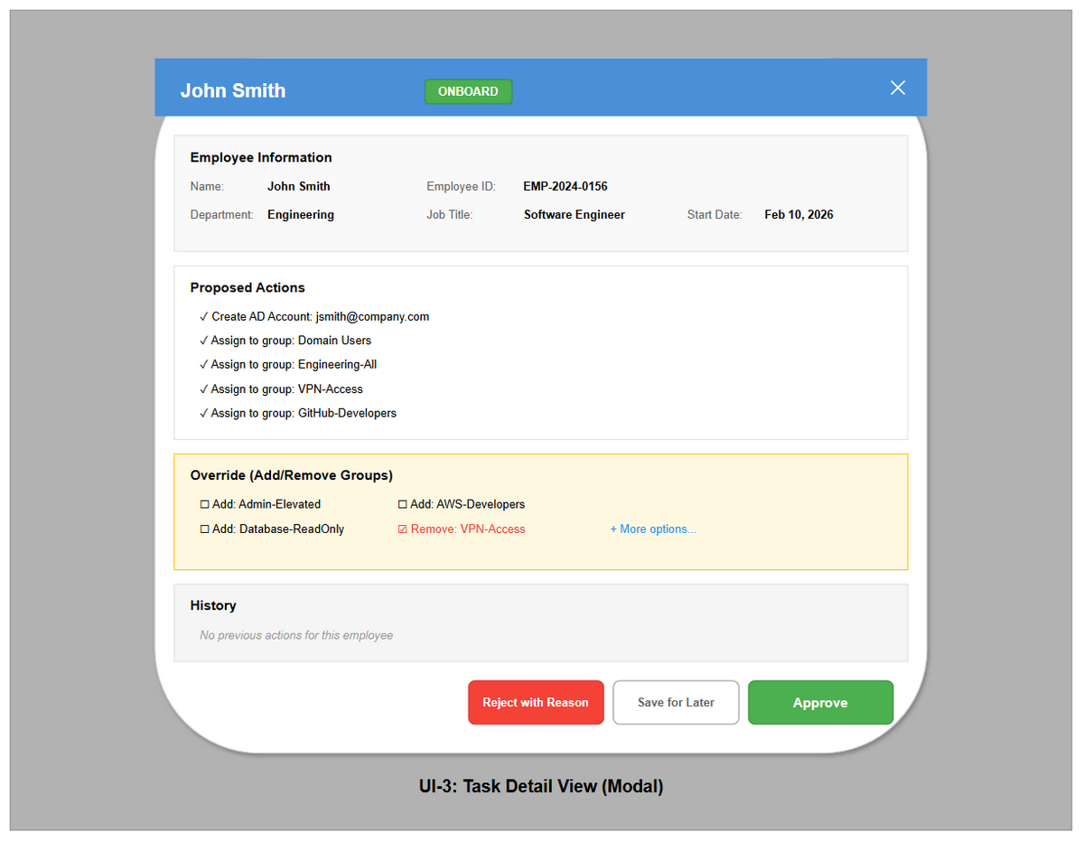

Input Controls and Buttons:
Control | Type | Location | Action
X Close | Icon button | Header, top-right | Closes the modal without taking any action
Override checkboxes | Checkbox | Override section | Check to add or remove specific AD security groups before approval
+ More options… | Hyperlink | Override section | Expands the list to show all available security groups
Reject with Reason | Button (red) | Footer | Opens a text prompt for a rejection reason, then cancels the task
Save for Later | Button (grey) | Modal footer | Saves override selections without executing. Task remains pending
Approve | Button (green) | Modal footer | Confirms the task with any overrides applied and queues it for execution

Display Elements: The modal header shows a blue banner with the employee name and a color-coded task type badge. The Employee Information section displays a read-only two-column grid of employee attributes including name, ID, department, job title, and start date. Proposed Actions lists each Active Directory operation to be performed, pre-populated from the role-permission mapping. The History section shows any prior lifecycle events for the same employee, which is useful for rehire scenarios.

Navigation: The Task Detail Modal is opened by clicking View Details on any task card on the Dashboard. Clicking Approve or Reject with Reason executes the chosen action and automatically closes the modal, returning the user to the Dashboard with the task list refreshed to reflect the change. Clicking Save for Later closes the modal without executing anything, leaving the task in a pending state. Clicking the close button dismisses the modal and returns the user to the Dashboard with no changes made.

2.4 Use Case 3 — Configure Role-Permission Mappings
The Mapping Configuration page allows the IT Administrator to define which Active Directory security groups are assigned to employees based on their department and job role. It is accessed via the Mappings link in the left sidebar.

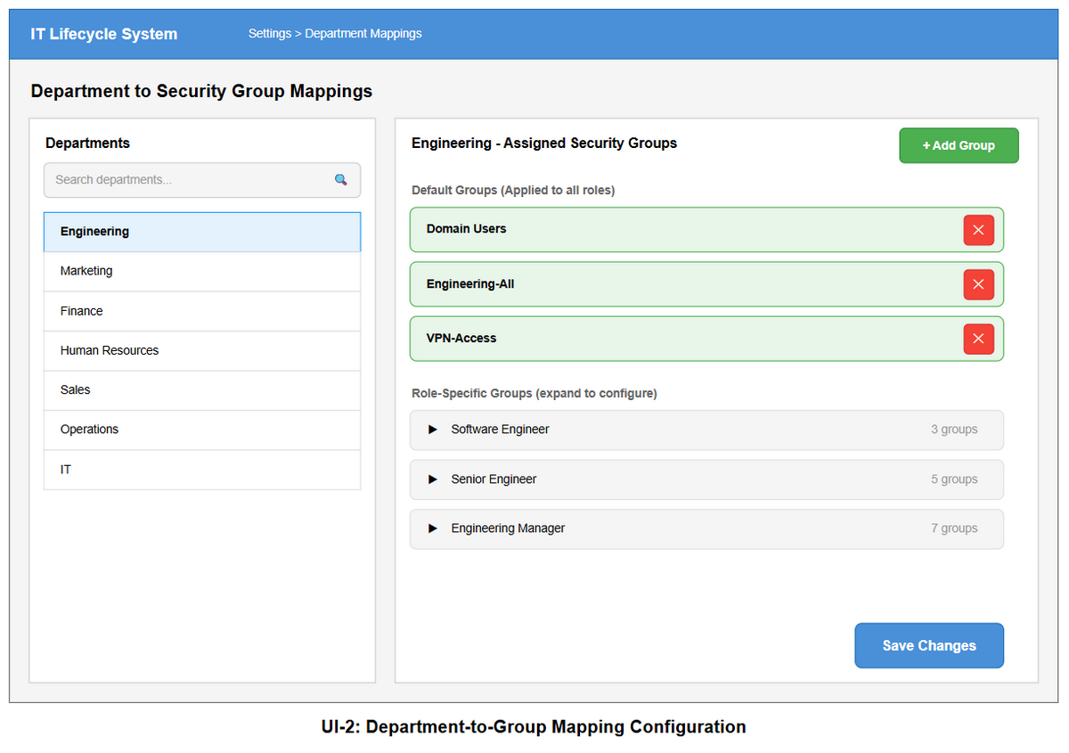

Input Controls and Buttons:
Control | Type | Location | Action
Search departments | Text input | Left panel, top | Filters the department list in real time as the user types
Department list items | Clickable rows | Left panel | Loads the selected department's group assignments in the right panel
Add Group | Button (green) | Right panel, top-right | Opens a picker to search for and add a new security group
(per group) | Icon button | Per assigned group row | Removes that security group from the department or role mapping
Role accordion rows | Expandable row | Role-Specific section | Expands to show or configure groups assigned to a specific job role
Save Changes | Button (blue) | Right panel, bottom-right | Persists all changes made to the current department's mappings

Display Elements: The left panel shows a scrollable list of all departments imported from OrangeHRM, with a search box at the top to filter the list. The active department is highlighted in blue. The right panel is divided into Default Groups, which are applied to all roles in the selected department, and Role Specific Groups, which are presented as expandable accordion rows organized by job title. Each assigned group row shows the group name and a red removal button. The breadcrumb in the top bar reads Settings > Department Mappings to indicate the user's current location.

Navigation: Users navigate to the Mapping Configuration page by clicking Mappings in the left sidebar from any screen in the application. Selecting a different department in the left panel updates the right panel to show that department's assignments without navigating to a new page. Clicking Add Group or expanding a role accordion are all in-page interactions that do not cause navigation. After making changes, clicking Save Changes persists the updates and displays a success notification within the same view.

2.5 Use Case 4 — View Audit Logs
The Audit Log Viewer provides a searchable, filterable, chronological record of all account lifecycle events. It is used by IT Administrators and Compliance Officers for troubleshooting and regulatory review.

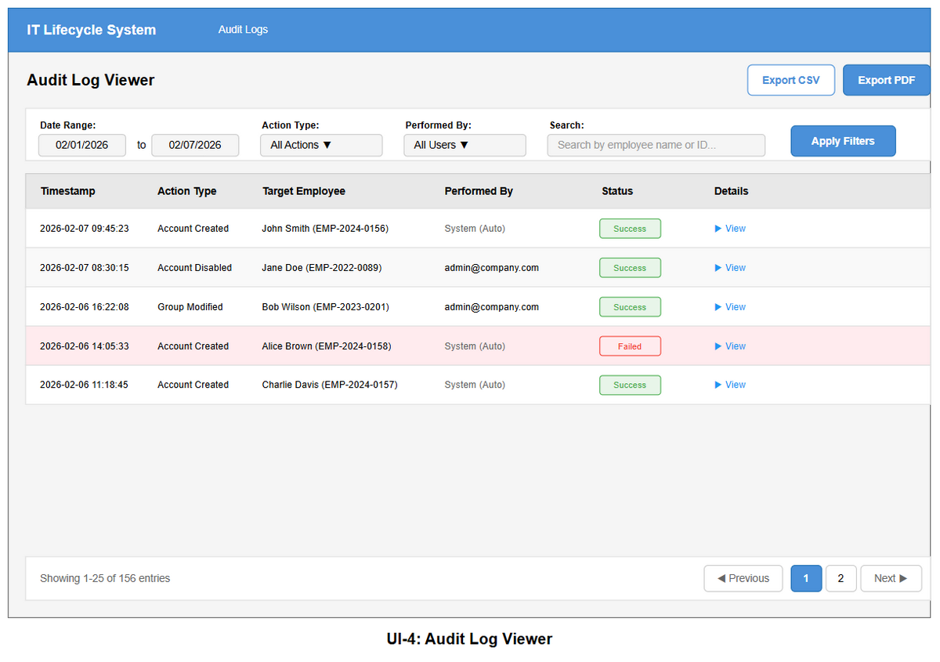
Input Controls and Buttons:
Control | Type | Location | Action
Date Range (start) | Date input | Filter bar | Sets the beginning of the log search window
Date Range (end) | Date input | Filter bar | Sets the end of the log search window
Action Type | Dropdown | Filter bar | Filters by action: All, Account Created, Account Disabled, Group Modified
Performed By | Dropdown | Filter bar | Filters by actor: All Users, System or a specific administrator
Search box | Text input | Filter bar | Free-text search by employee name or employee ID
Apply Filters | Button (blue) | Filter bar, right | Submits all filter criteria and refreshes the log table
Export CSV | Button | Page header | Downloads the filtered log data as a CSV file
Export PDF | Button (blue) | Page header | Downloads the filtered log as a formatted PDF document
View | Text link | Table, last column | Opens a full detail view for that specific log entry
Previous / Next | Pagination buttons | Table footer | Navigates between pages of results

Display Elements: Failed log rows are highlighted with a light red background to draw attention. The Status column uses color-coded badges showing green for Success and red for Failed. The Performed By column shows System (Auto) for automated actions and the administrator's email address for manual actions. A pagination row at the bottom shows the total result count and the current page range.

Navigation: Users navigate to the Audit Log Viewer by clicking Audit Logs in the left sidebar from any screen. The page loads automatically with a default date range covering the past seven days. Setting filter criteria and clicking Apply Filters refreshes the results table in place without leaving the page. Clicking Export CSV or Export PDF initiates a file download immediately without any page navigation. Clicking the View link on any table row opens a detailed view of that specific log entry. The pagination controls at the bottom allow the user to move through large result sets page by page.

2.6 Use Case 5 — Generate Compliance Reports
The Report Generation page allows IT Administrators to configure and preview compliance, activity summary, or failed-action reports for a specified date range and optional department filter. Reports can be downloaded as PDF or CSV, or emailed directly to the administrator.

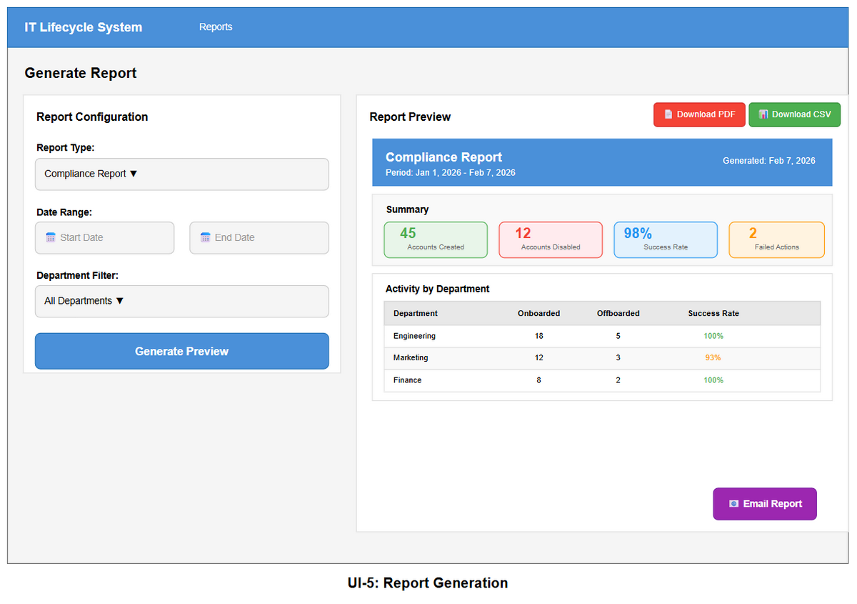

Input Controls and Buttons:
Control | Type | Location | Action
Report Type | Dropdown | Config panel | Selects the report type: Compliance, Activity Summary, or Failed Actions
Start Date | Date picker | Config panel | Sets the start of the report period
End Date | Date picker | Config panel | Sets the end of the report period
Dept. Filter | Dropdown | Config panel | Filters by department; defaults to All Departments
Generate Preview | Button (blue) | Config panel, bottom | Queries data and renders the report in the right-hand preview panel
Download PDF | Button (red) | Preview panel, top-right | Exports the previewed report as a downloadable PDF
Download CSV | Button (green) | Preview panel, top-right | Exports the underlying report data as a CSV file
Email Report | Button (purple) | Preview panel, bottom-right | Sends the generated report to the logged-in user's email address

Display Elements: The configuration panel on the left collects all report parameters before generation. The preview panel on the right renders a formatted report containing a header with the report title and date range, a row of summary statistic cards color-coded by outcome (green for accounts created, red for accounts disabled, blue for success rate, orange for failed actions), and a department breakdown table showing onboarding and offboarding counts per department. The Download PDF, Download CSV, and Email Report buttons in the preview panel are only active after Generate Preview has been clicked.

Navigation: Users navigate to the Report Generation page by clicking Reports in the left sidebar. The page loads with an empty preview panel and all configuration fields set to their defaults. Selecting report parameters and clicking Generate Preview populates the preview panel on the right side of the same page without any navigation. Clicking Download PDF or Download CSV begins a file download directly from the browser without leaving the page. Clicking Email Report sends the report to the administrator's registered email address and displays a confirmation notification.

2.7 Use Case 6 — Search Employee Status
The Employee Search page allows any authorized user to look up employees by name, ID, or email and immediately view their current Active Directory account status. IT Administrators and HR Personnel use this for quick status checks without navigating the full task queue.

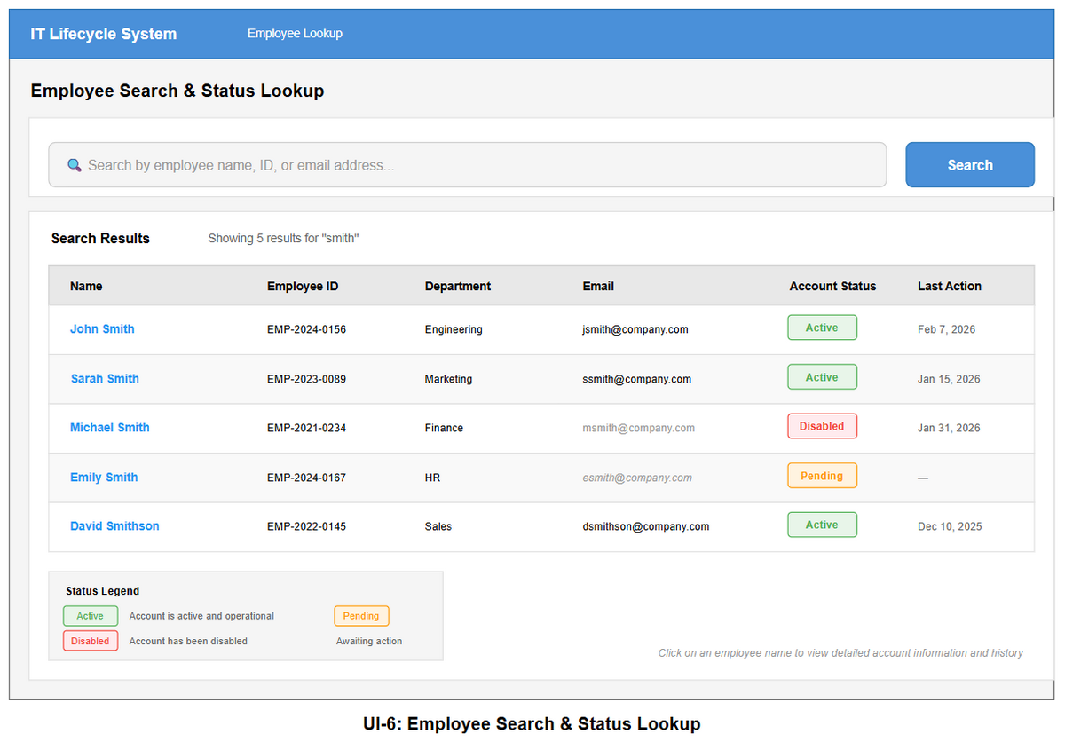

Input Controls and Buttons:
Control | Type | Location | Action
Search box | Text input | Search bar | Accepts free text: employee name, ID number, or email address
Search | Button (blue) | Search bar, right | Submits the query and populates the results table
Employee name | Hyperlink | Results table, Name column | Opens the employee's detailed account information and history

Display Elements: The results table displays the following columns for each matching employee: Nam, Employee ID, Department, Email, Account Status badge, and Last Action date. Account Status badges are color-coded with green for Active, red for Disabled, and orange for Pending. Employees whose accounts have been disabled have their email address shown with a strikethrough style. A legend at the bottom of the results section explains the three status colors. A hint below the table reads: Click on an employee name to view detailed account information and history.

Navigation: Users navigate to the Employee Search page by clicking Employee Lookup in the top navigation bar or through the sidebar. The page loads with an empty search box and no results displayed. After entering a search query and clicking Search or pressing Enter, the results table below the search bar populates with matching employees. Clicking an employee's name in the results table navigates to that employee's detailed account information and lifecycle history view.

3. User Effort Estimation
Assumptions:
- The user is already logged in and on the Dashboard.
- A date picker selection costs 2 clicks (open field, select day). Standard cases assume no month navigation is required.
- A dropdown selection costs 2 clicks (open dropdown + select option).
- Pressing Enter to submit a form counts as 1 keystroke, not a click.

Scenario A — Quick-Approve a Pending Onboarding Task
Actor: IT Administrator. Goal: Approve a pending onboarding task directly from the Dashboard without modifying any groups.
Step | Action | Clicks | Keystrokes
1 | Starting point: Dashboard is open showing pending tasks | 0 | 0
2 | Click Approve on the target task card | 1 | 0
3 | Confirmation dialog appears — click Confirm | 1 | 0
Total |  | 2 | 0

Scenario B — Review and Approve with a Group Override
Actor: IT Administrator. Goal: Open a task's detail view, remove one security group, add one group, then approve.
Step | Action | Clicks | Keystrokes
1 | Starting point: Dashboard is open | 0 | 0
2 | Click View Details on the target task card | 1 | 0
3 | Task Detail Modal opens; review employee info (read-only) | 0 | 0
4 | Check the Remove: VPN-Access checkbox in the Override section | 1 | 0
5 | Click + More options to expand the full group list | 1 | 0
6 | Check the Add: AWS-Developers checkbox | 1 | 0
7 | Click Approve | 1 | 0
8 | Confirmation dialog — click Confirm | 1 | 0
Total |  | 6 | 0

Scenario C — Search for an Employee by Name
Actor: IT Administrator or HR Personnel. Goal: Look up the account status for an employee named Smith.
Step | Action | Clicks | Keystrokes
1 | Starting point: Dashboard | 0 | 0
2 | Click Employee Lookup navigation link | 1 | 0
3 | Click on the search box | 1 | 0
4 | Type smith (5 characters) | 0 | 5
5 | Press Enter to submit (or click Search button) | 0–1 | 0–1
6 | Click employee name in results table to view their detail | 1 | 0
Total |  | 3–4 clicks | 5–6 keystrokes

Scenario D — Add a New Department-Role-Group Mapping
Actor: IT Administrator. Goal: Add the AWS-Developers AD group to the Senior Engineer role in the Engineering department.
Step | Action | Clicks | Keystrokes
1 | Starting point: Dashboard | 0 | 0
2 | Click Mappings in the sidebar | 1 | 0
3 | Click Engineering in the department list | 1 | 0
4 | Click the Senior Engineer accordion row to expand it | 1 | 0
5 | Click + Add Group | 1 | 0
6 | Group picker input appears; click the search field | 1 | 0
7 | Type AWS-Dev to filter results (7 characters) | 0 | 7
8 | Click AWS-Developers from the suggestion list | 1 | 0
9 | Click Save Changes | 1 | 0
Total |  | 7 | 7

Scenario E — Generate and Download a Compliance Report
Actor: IT Administrator. Goal: Generate a Compliance Report for January 2026, filtered to the Engineering department, and download as PDF.
Step | Action | Clicks | Keystrokes
1 | Starting point: Dashboard | 0 | 0
2 | Click Reports in the sidebar | 1 | 0
3 | Click the Report Type dropdown | 1 | 0
4 | Select Compliance Report | 1 | 0
5 | Click the Start Date picker — select Jan 1, 2026 | 2 | 0
6 | Click the End Date picker — select Jan 31, 2026 | 2 | 0
7 | Click the Department Filter dropdown | 1 | 0
8 | Select Engineering | 1 | 0
9 | Click Generate Preview | 1 | 0
10 | Review preview (no input required) | 0 | 0
11 | Click Download PDF | 1 | 0
Total |  | 11 | 0

Scenario F — Filter Audit Logs for Failed Actions
Actor: IT Administrator or Compliance Officer. Goal: Filter audit logs to show only failed actions from the past 7 days.
Step | Action | Clicks | Keystrokes
1 | Starting point: Dashboard | 0 | 0
2 | Click Audit Logs in the sidebar | 1 | 0
3 | Default date range (last 7 days) is pre-filled — no change needed | 0 | 0
4 | Click the Action Type dropdown | 1 | 0
5 | Select Failed from the dropdown | 1 | 0
6 | Click Apply Filters | 1 | 0
7 | Filtered results appear; click View on a failed entry | 1 | 0
Total |  | 5 | 0

3.7 Summary
Scenario | Description | Mouse Clicks | Keystrokes | Total
A | Quick-approve a pending task | 2 | 0 | 2
B | Approve with group override | 6 | 0 | 6
C | Search for employee by name | 3–4 | 5–6 | 9–10
D | Add a new group mapping | 7 | 7 | 14
E | Generate and download a report | 11 | 0 | 11
F | Filter audit logs for failed actions | 5 | 0 | 5

The most common operations of approving a task (2 clicks), viewing audit logs (5 clicks), and searching for an employee (4 clicks and 5 keystrokes) require very few interactions, consistent with the system goal of reducing manual IT workload. The highest-effort scenario is generating a filtered report (11 clicks), which is unavoidable given the number of configurable parameters needed.

